Product Overview
Ranger® Irrigation Fluid Warming

Introduction

Irrigation Disposable
The irrigation fluid warming set is designed for flow rates from 0 to 865mL/min. Higher flow rates and larger volumes of fluid are commonly associated with procedures where irrigation in needed. The irrigation fluid warming set can be used as a gravity flow system or with pressure infusion up to 300 mmHg. The patient line is contained within its own sterile packaging for use within the sterile field and includes a standard scope attachment. The patient line can easily be disconnected after a procedure and reconnected to the patient line for
use during post surgical irrigation.
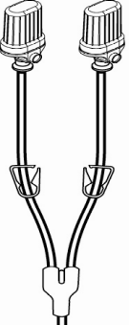
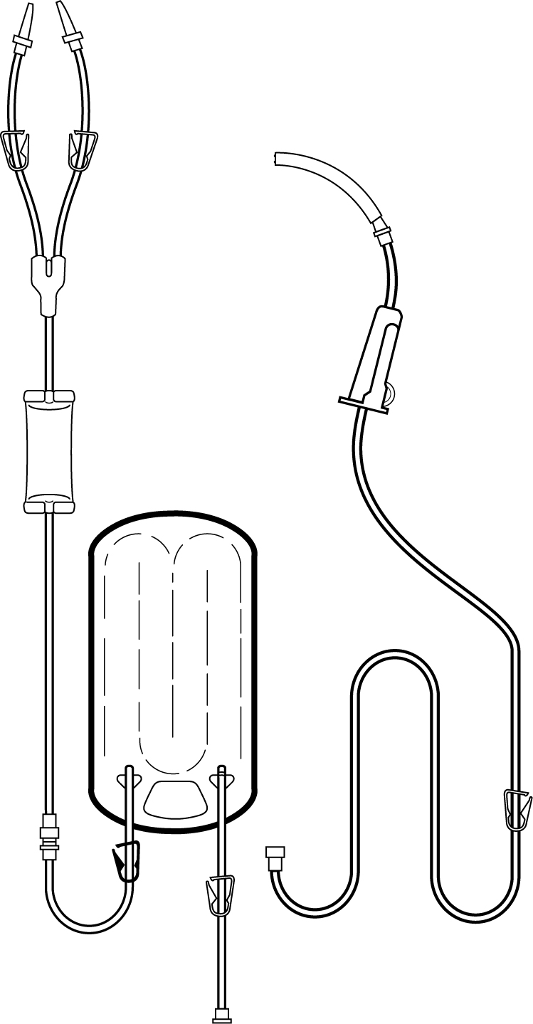
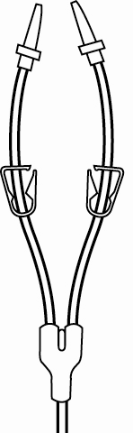
(b)
4
5
2
6
7
1
3
(c)
8
(a)

Irrigation Set Components, Latex--free
- Spike set: Standard (a), bottle (b), and Easyflow® (c) spike sets are available.
- Heat exchanger: Inserts into the warming unit and actively warms the fluid inside the pathway.
- Drip chamber: To monitor fluid flow and assist in priming.
- Proximal pinch clamp: To stop flow while draining the fluid from the warming set after the completion of surgery.
- Distal pinch clamps: To start or stop flow.
- Roller clamp: To regulate flow rate.
- Patient line / Cysto-tubing: Packaged in its own sterile pouch. Can connect disposable set to scope, Foley catheter*, or wand.
- Check Valve: To prevent back flow of fluid.
* A Foley catheter is a thin, sterile tube inserted into your bladder to drain urine. Because it can be left in place in the bladder for a period of time, it is also called an indwelling catheter. It is held in place with a balloon at the end, which is filled with sterile water to hold it in place. The urine drains into a bag and can then be taken from an outlet device to be drained. Laboratory tests can be conducted on your urine to look for infection, blood, muscle breakdown, crystals, electrolytes, and kidney function.

Irrigation Warming Unit
The Ranger irrigation warming unit is for use with the Ranger irrigation set only. Both the warming unit and set have been keyed so that they can only be used for irrigation fluid warming. Ranger IV blood and fluid warming sets will not fit into the irrigation warming unit and the irrigation set will not fit into the Ranger blood and fluid warming unit. In addition, the irrigation warming unit is a different color than the Ranger blood and fluid warming unit and is clearly labeled for irrigation only.

Irrigation Warming Unit Components
1) Temperature Display: Clearly indicates normal operating temperature and any under or over temperature alarm conditions.
1
7
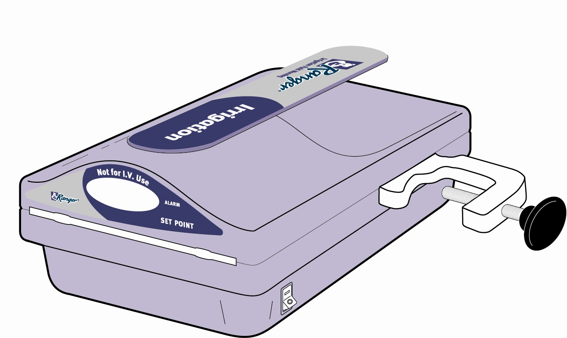
2) Keyed Cassette Slots: Makes insertion of the irrigation set quick and easy and the insertion of IV cassettes impossible.
3) Warming plates: Highly conductive aluminum heating plates disperse heat immediately, handling sudden changes in flow rates with ease.
4) Power Switch: The Ranger warming unit is ready to warm in less than two minutes
6
5
5) Internal Temperature Sensor: The Ranger system’s software monitors temperature four times each second and adjusts the heat level to maintain a 41° C set point.
2
4
3
6) Pole Clamp: Universal pole clamp fits standard IV pole and 2”-square irrigation pole
7) Easy to clean surface: Simply wipe down with any non-abrasive disinfectant

Product Specifications
Irrigation Fluid Warming Set – PN# 24760
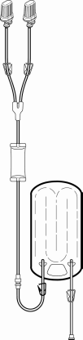

Flow rates: 0-865 mL/min (with the bag hung 100 cm above
the scope under gravity flow)
Priming volume: 216 mL
Components: Double rigid bottle spike set, drip chamber,
heat exchanger
Material: Latex-free
Case quantity: 10 sets/case
Sterile: EtO
Use: Multi-use

Irrigation Fluid Warming Patient Line – PN# 24765
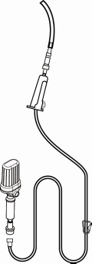
Flow rates: 0-865 mL/min (with the bag hung 100 cm
above the scope under gravity flow)
Priming volume: 92 mL
Patient line length: 213 cm
Components: Single rigid bottle spike, drip chamber,
patient line with scope attachment (patient line is contained
within its own sterile packaging for use within the sterile field),
check valve
Material: Latex-free
Case quantity: 10 sets/case
Sterile: EtO
Use: Singe use only

Irrigation Fluid Warming Set – PN# 24770
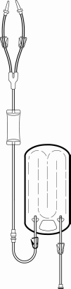

Flow rates: 0-865 mL/min (with the bag hung 100 cm above
the scope under gravity flow)
Priming volume: 216 mL
Components: Double standard spike set, drip chamber,
heat exchanger
Material: Latex-free
Case quantity: 10 sets/case
Sterile: EtO
Use: Multi-use

Irrigation Fluid Warming Patient Line – PN# 24775
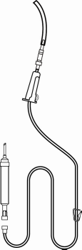

Flow rates: 0-865 mL/min (with the bag hung 100 cm above
the scope under gravity flow)
Priming volume: 92 mL
Patient line length: 213 cm
Components: Single standard spike set, drip chamber,
patient line with scope attachment (patient line is contained
within its own sterile packaging for use within the sterile field),
check valve
Material: Latex-free
Case quantity: 10 sets/case
Sterile: EtO
Use: Singe use only

Product Specifications

Irrigation Fluid Warming Set – PN# 24780

Flow rates: 0-865 mL/min (with the bag hung 100 cm above
the scope under gravity flow)
Priming volume: 216 mL
Components: Double Baxter® Easyflow® spike set, drip chamber,
heat exchanger
Material: Latex-free
Case quantity: 10 sets/case
Sterile: EtO
Use: Multi-use

Irrigation Fluid Warming Patient Line – PN# 24785

Flow rates: 0-865 mL/min (with the bag hung 100 cm above
the scope under gravity flow)
Priming volume: 92 mL
Patient line length: 213 cm
Components: Single Baxter® Easyflow® spike set, drip chamber,
patient line with scope attachment (patient line is contained
within its own sterile packaging for use within the sterile field),
check valve
Material: Latex-free
Case quantity: 10 sets/case
Sterile: EtO
Use: Singe use only

Warming Unit – PN# 24700

Set point temperature: 41°C
Alarms: Over-temperature primary set point = 48°C
Over-temperature secondary set point = 50°C
Under-temperature set point = 33°C
Power: 220VAC
Weight: 7 lbs. 7 oz
Dimensions: 19X11X25cm

